Task Number: Task 3
Project: Titanic Survival Prediction
Name: Gopala Vishalini
Internship: Alfido Tech

GitHub:
https://github.com/VishaliniGopala/Titanic-Survival-Prediction

Model File:
https://drive.google.com/file/d/1Vmp5rRN6lk38roRMqYwoU-JLV00ZcMUq/view

Screenshots: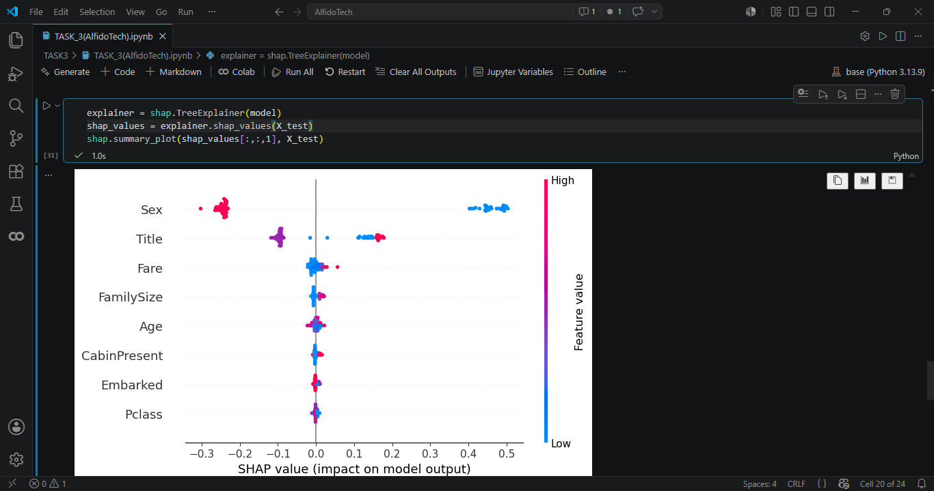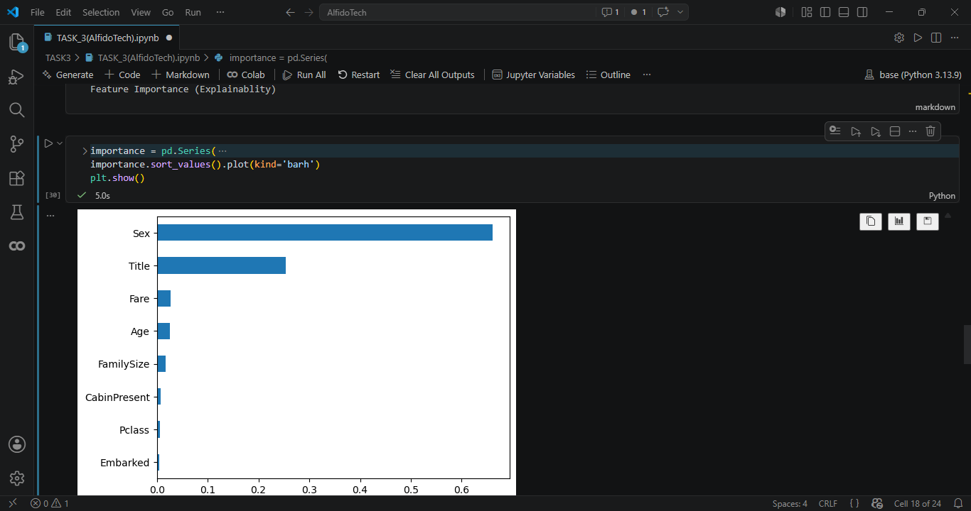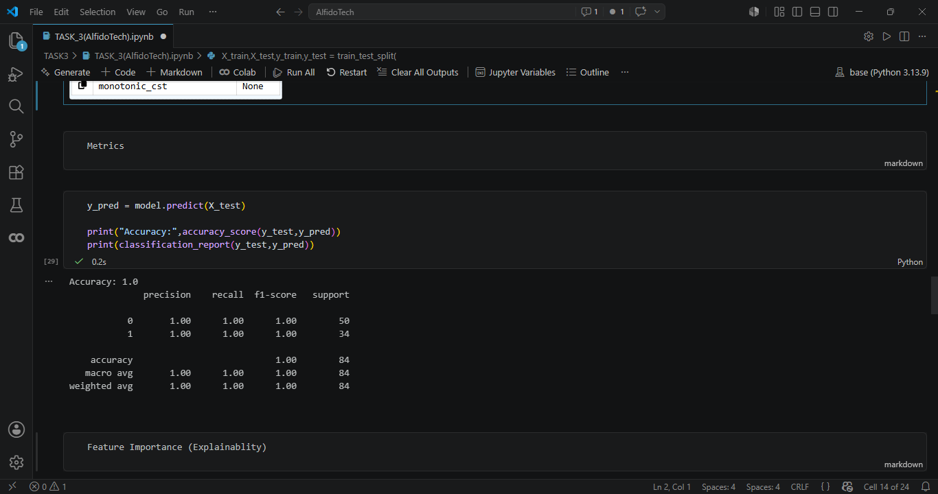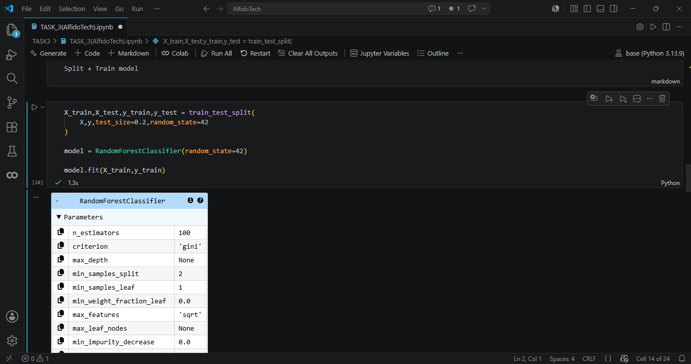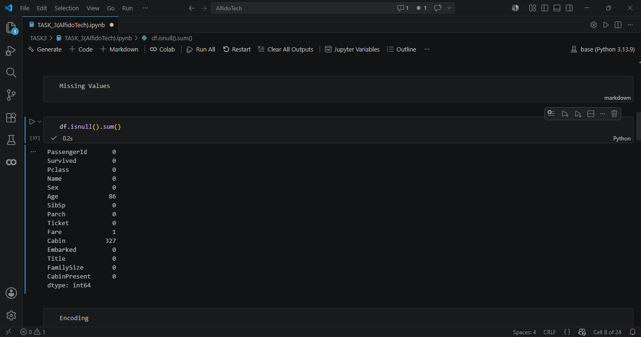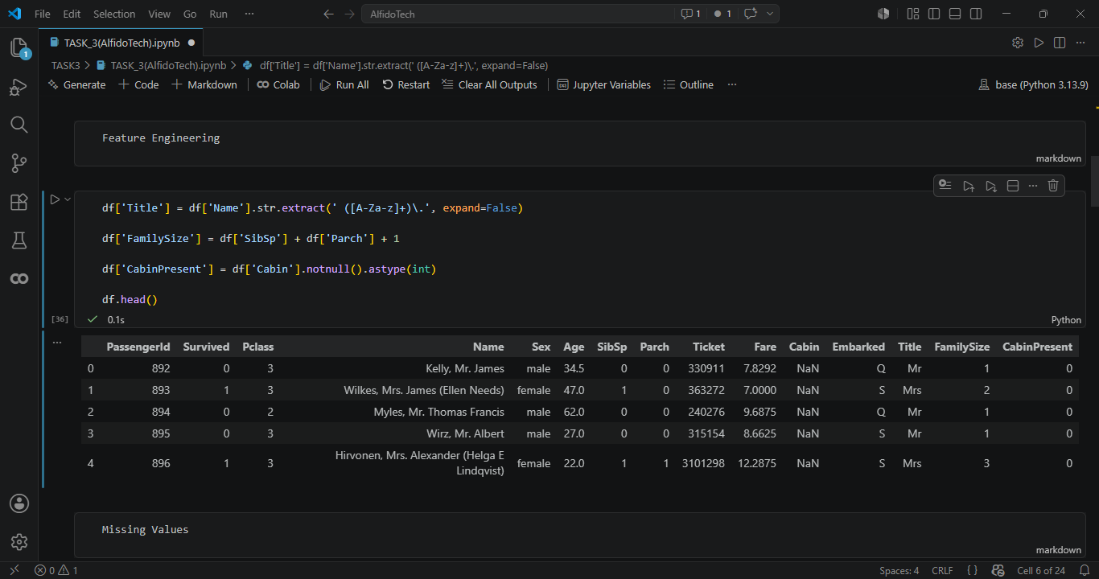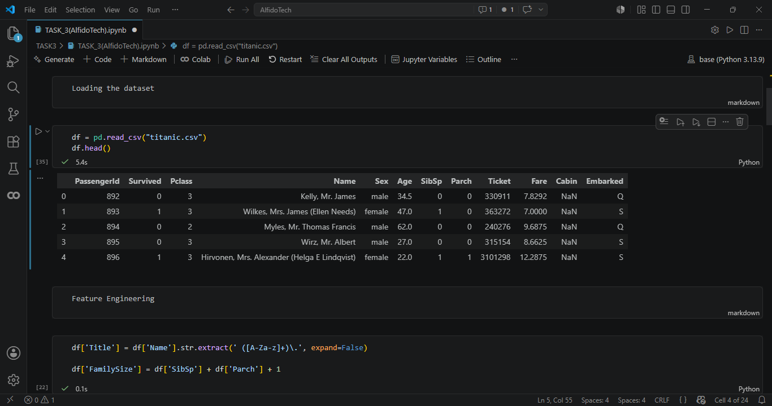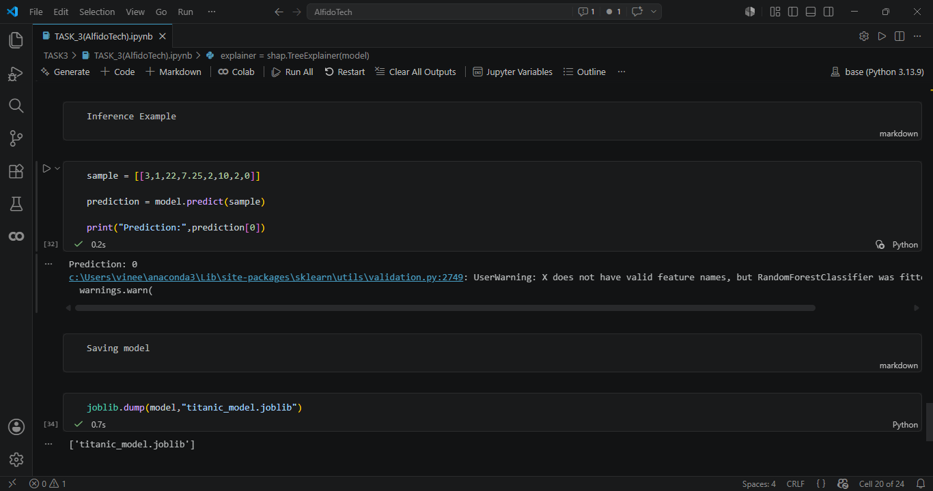

Summary — Task 3: Titanic Survival Prediction
Objective
The objective of this project was to develop a machine learning classification model to predict passenger survival on the Titanic using passenger details and travel-related attributes. The dataset included features such as passenger class, gender, age, fare, cabin information, family details, and embarkation location. The target variable for prediction was Survived.
Methodology
The project began with data preprocessing and exploratory analysis to understand dataset structure, feature characteristics, and missing values. Initial analysis involved dataset inspection using methods such as head(), info(), describe(), and missing value checking.
Feature engineering and preprocessing techniques were applied to improve model performance. This included:
• Title extraction from passenger names (Mr, Mrs, Miss, etc.)
• Family size creation using siblings/spouse and parents/children information
• Cabin presence feature generation
• Missing value handling for Age, Cabin, and Embarked columns
• Label Encoding for categorical variables
• Feature selection for model training
The processed dataset was then divided into training and testing sets for model development and evaluation.
Model Implemented
The following classification algorithm was trained:
- Random Forest Classifier
The model was selected due to its ability to handle mixed feature types and provide feature importance for explainability.
Model Explainability
To interpret model predictions and feature influence, explainability techniques were applied:
• Feature Importance Analysis
• SHAP (SHapley Additive exPlanations) Summary Plot
These methods helped identify the most influential features contributing to passenger survival prediction.
Evaluation Metrics
Model performance was evaluated using classification metrics:
• Accuracy Score
• Precision
• Recall
• F1-Score
• Classification Report
These metrics were used to assess the predictive performance and reliability of the classification model.
Results and Outcome
The implemented model successfully predicted Titanic passenger survival using engineered and preprocessed features. Feature engineering techniques such as title extraction, family size generation, and cabin presence improved the dataset representation for learning.
The trained model was saved using Joblib for future inference and reproducibility. An inference example was also included to demonstrate how new passenger information can be provided to the saved model for generating survival predictions.
Technologies Used
The project was implemented using:
• Python
• Pandas
• Matplotlib
• Scikit-Learn
• SHAP
• Joblib
Conclusion
This project successfully developed a machine learning-based Titanic survival prediction system using preprocessing, feature engineering, classification modeling, and explainable AI techniques. The implementation demonstrates a complete end-to-end machine learning workflow, from data preparation and model training to evaluation, interpretation, and deployment-ready model saving.

